Pg. 129 – 130, Java Programming *A comprehensive Introduction*

Class and Object expanded - Continued

**Section 1: Define / Answer**

“programmer created” class- How do “programmer created methods” using **void**, differ from using created using **return**? Briefly - Define how return works.

The differences between using void and using return are if you are using void, you couldn’t return any interger type such as Double, float, Int. But If you are using return, you must return the interger type.

And if you use void, the systax should be

void something() {

}

and if you use return, the systax should be

public int something() {

int I = 0

return I;

}

Pg. 123, Java Programming *A comprehensive Introduction*

**Programming Assignment**

Task 1- Create a computer program that will calculate the range for 3 different vehicles.

The program should create a “programmer created” class, where 3 **int** **objects** are created passengers, fuel capacity, mpg.

Set-up the program so the user can manually input the values for passengers, fuel capacity, mpg for the 3 created vehicles.

Create a **return** method inside the “programmer created “ class to calculate vehicle range**.**

**range =** **fuel capacity * miles per gallon**.

Each Vehicle type should have unique values for number of passengers, fuel capacity, and miles per gallon.

Follow the sample below and return information on 3 vehicle types.

**Sample Output: // Create similar output for 3 Vehicle Types**

The minivan carries= 7

The minivan has a fuel capacity of = 16

The minivan mpg = 21

The minivan has a range of: 336 miles

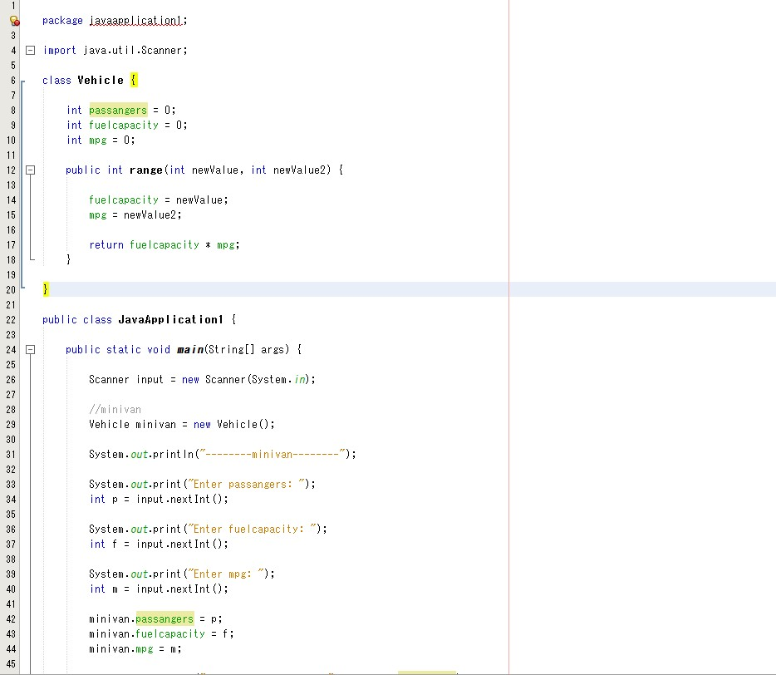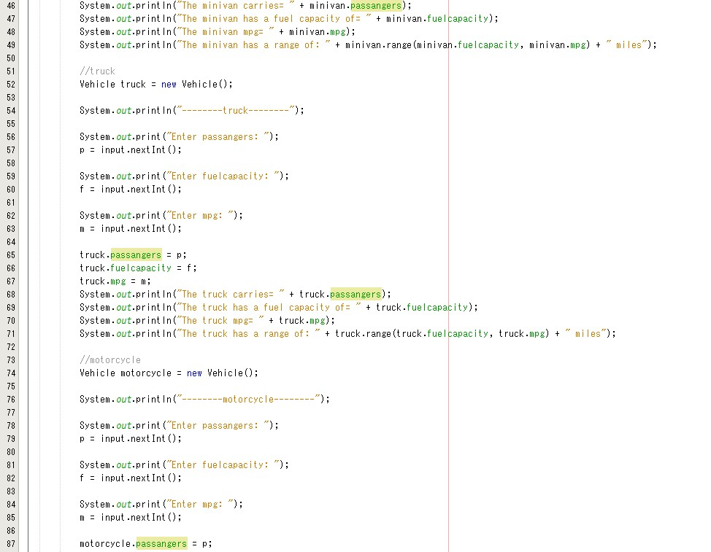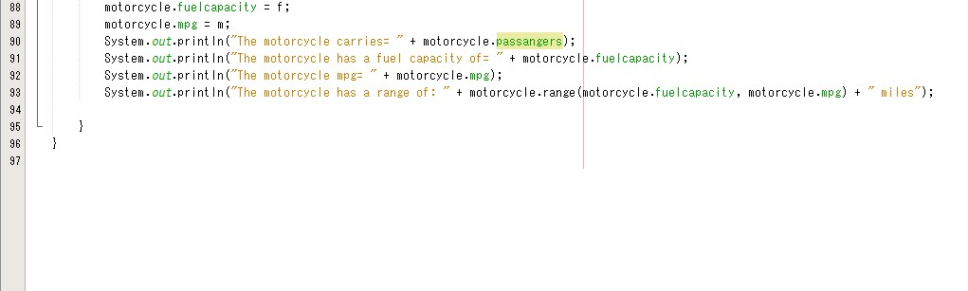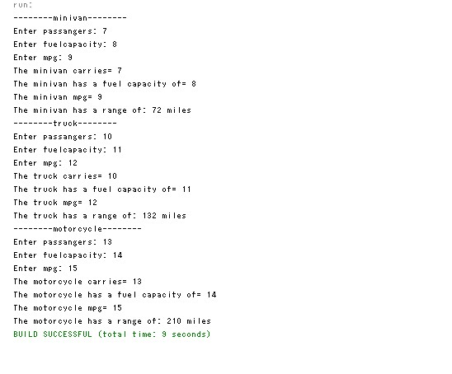

Task 2 - Write a program that computes a single filer’s income tax burden.

|  |  |
| --- | --- |
| **TAX RATE** | **Single Filers Income** |
| 10% | Up to $6000 |
| 15% | $6,001 - $27,950 |
| 27% | $27,951 - $67,700 |
| 30% | $67,701 - $141,250 |
| 35% | $141,251 - $307,050 |
| 38.6% | $307, 051 or more |

The user should be able input her income using **new** Scanner (System.in), input method and then be returned the amount of tax owed.

All source code for solving the problem and handling user input should be created in a “programmer created class.”

Use **return** for retrieving all values from calculations or **if/else** statements etc.

**main** will be used to operate the program.

Output should have proper formatting for dollars, 2 decimal places.

**Sample Output- //**Output should have proper formatting for dollars, 2 decimal places

Income tax for a single person making $85000.00 is $25500.00

Income tax for a single person making $9800.00 is $1470.00

